**Chatbot For HR Department**

Rishikesh Nanaware , Ajay Kushawaha, Damini Pandare, Prof. Nileema Pathak

Department of Information Technology, Atharva College of Engineering,

***Abstract --*****Chatbots are programs that mimic human conversation using Artificial Intelligence (AI). It is designed to be the ultimate virtual assistant. This chatbot can be used by any business to answer FAQs to curious HRs in an interactive fashion. It is challenging task for HR people to find accurate data in huge databases regarding their queries. It is also tedious task to search particular tuple like finding data of particular employee. To simplify this problem we have designed a Chatbot for HR department, which will be able to answer FAQs related to HR department. In this paper we have proposed design of a Chatbot which will respond to user using Artificial Intelligence Markup Language(AIML) and Latent Semantic Analysis(LSA). Query is tested with Artificial Intelligence Markup Language (AIML). If template is found then it searches in database for results and returns result. Else it is handled with Latent Semantic Analysis (LSA) and returns result from database.**

***Keywords – Chatbot, AIML, LSA, HR department***

**INTRODUCTION**

* 1. **NEED**

Today’s world is running very fast, so HRs don’t have much time to look personally into the database to find answers to their queries. They need some fast approach to do their work. There is a need for an assistant who can work faster. So it is better if they have a virtual computer-based assistant which can answer fast to their queries. A simple virtual assistant is a Chatbot. In the past few years, Chatbots have been very popular because of their fast and accurate response capability and less need for any physical resources as they are not paid. Using Chatbot will reduce and make faster the work of HR people effectively increasing the productivity of them.

* 1. **PROBLEM STATEMENT**

To overcome with these problems, we have designed a Chatbot for HR department to give virtual assistance to HR people to let them simplify their work and increase their productivity.

* 1. **AIMS AND OBJECTIVES**
* **AIM**:

The Chatbot for HR department aims to provide efficient and accurate answers for queries asked by HRs from the database using Artificial Intelligence Markup Language (AIML) and Latent Semantic Analysis (LSA).

* **Objective:**

To give virtual assistance to HRs so their work could be simplified and productivity could be increased.

* 1. **APPLICATION AND SCOPE**
* **APPLICATION:**

A HR can ask queries related to employee details and Chatbot will give response to those queries.

* **SCOPE:**

This system answers to queries of HR people using AIML and LSA. Hence leading to faster operations and increased productivity of HR people. This system is also very cost efficient, fast and user-friendly as most of the work is done by Chatbot which is computer program.

**PROPOSED MODEL**

In this paper, we have proposed a chatbot who will help the HR department to find answers to their queries by just typing in the chat window. Our system uses technologies Artificial Intelligence Markup Language(AIML) and Latent Semantic Analysis(LSA). The workflow of the proposed system is shown in Figure 1. Workflow of Chatbot for HR department.

First, the bot-user has to enter a query in the chatbox. After that AIML developed chatbot will match the pattern and will give a proper response. If the response is to be fetched from the database, it will be handled by LSA. LSA will catch query and try to identify the correct requirements of the user and after that, it will fetch results from the database using python. Once chatbot got the response for the user entered query it will show it as a response in the chatbox.

Section 1) Template based responses:

Template based queries like greetings would be handled by Artificial Intelligence Markup Language (AIML). AIML will match the user entered query with the pattern defined in the AIML files and if pattern matches it will give the stored response.

For example,

Human: Hello

Bot: Hi

Section 2) General queries:

General queries cannot be handled by only AIML, it needs the help of Latent Semantic Analysis (LSA), as we cannot store every pattern user can enter. So we generalize some part of query and other part will be handled by LSA.

For example,

Human: Give me salary of Prakash Parmar

Bot: 65000 Rs.

It can be seen that to get salary of employee different user can type various queries. So we store pattern for **Give** and **salary** by using LSA which will give same result for all salary requests.

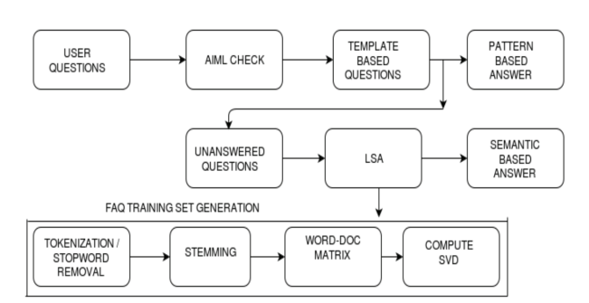

Figure 1. Workflow of Chatbot for HR department

**CONCLUSION**

This project will definitely simplify the work of HR department by finding accurate answers to their questions. Chatbot developed will be continuously developing and learning from the data which is new to the system. Using this system HR department will no longer have to search in huge databases for their questions.

**REFERENCES**

1. Chatbot for University Related FAQs, Bhavika R. Ranoliya , Nidhi Raghuwanshi and Sanjay Singh, International Conference on Advances In Computing Communications and Informatics 2017
2. Automated Thai-FAQ Chatbot using RNN-LSTM, Panitan Muangkammuen,Narong Intiruk ,Kanda Runapongsa Saikaew , 22nd International Computer Science and Engineering Conference 2018
3. Intelligent Chatting Service Using AIML , Saqib G, Faizan , Ghatte N , IEEE International Conference on Current Trends toward Converging Technologies, 2018